**Deploying Mellanox What Just Happen dashboards on Grafana**

1. Install Telegraf, InfluxDB, and Grafana
2. Use the following configuration <https://github.com/Mellanox/wjhgraf/blob/master/telegraf.conf> in: /etc/telegraf/telegraf.conf
3. Add Telegraf as datasource of Grafana if it isn't already added

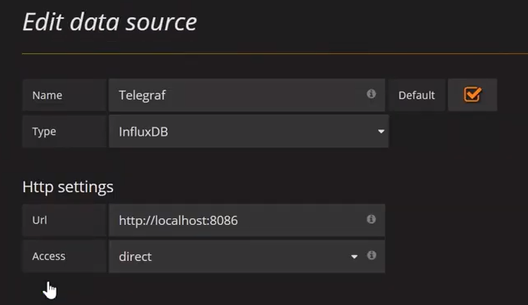

1. Import both Monitoring and Debug dashboards to grafana:

<https://grafana.com/dashboards/10247>

<https://grafana.com/dashboards/10248>